



**www.ortho-ped.com**



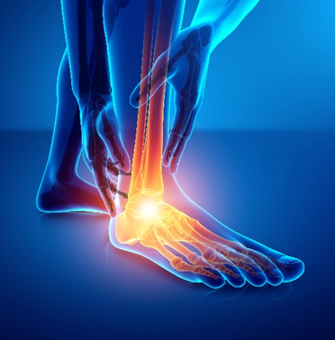**FOOT & ANKLE**

**SUPPORTS**

**Pro AIR WALKER BOOT 11” & 17”**

**HCPCS: L4361**

The air walker boot with contoured strut design for maximum

stability, soft tissue injuries (grade 2 and 3 sprains), fractures.

1) Push button release valve

Cushioned heel for greater energy absorption and greater patient comfort.

2) Foot section can accommodate full dressings and padding

3) New lightweight design sole unit to greatly improve shock absorption

4) Comfortable detachable liner with replacements available

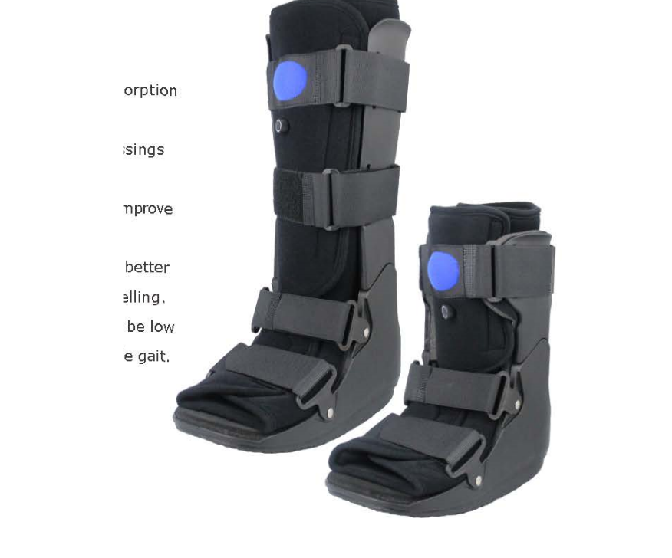 5) Rocker bottom is specially engineered to be low and wide to help promote a natural stable gait

Indications for Use:

Post op ankle stabilization

Stress fractures

Stable ankle fractures

Soft tissue and ligament

injuries

**Size: XS, S, M, L, XL**

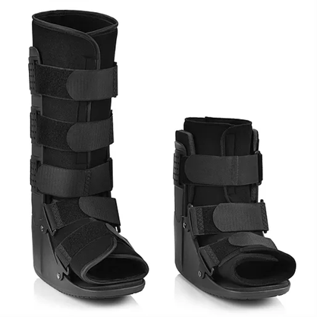**Ultimate Polymer Walker Non-Air 11” & 17”**

**HCPCs - L4386**

Indications:

Ankle and leg protection

Decrease pain symptoms

Improve healing time

Immobilization of fractures

Improve ambulation during post-op and post-surgery

Features:

Slotted polymer uprights that hold hook and loop straps in place

Skid resistant rocker sole

Accommodates swelling that occur throughout the rehabilitation process

Lightweight, low profile construction provided stability

Wide foot bed for increased stability

**Size: XS, S, M, L, XL**

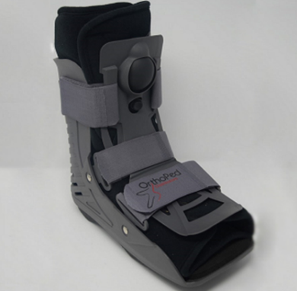

**AIR ULTRALIGHT WALKING BOOT 11” & 17”**

Indications:

Ankle and leg protection

Decrease pain symptoms

Improve healing time

Immobilization of fractures

Improve ambulation during post-op and post-surgery

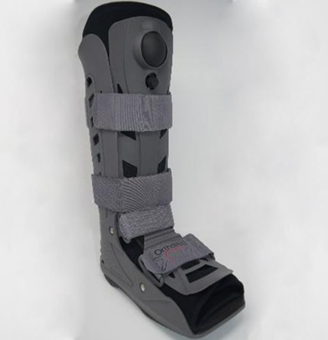**Features:**

Cushioned heel for greater energy absorption

and patient comfort.

Front panel and ankle straps provide more stability.

New lightweight design sole improves shock absorption.

Inflatable foam liner can be adjusted for better support

and comfort while reducing swelling.

Push press release valve button.

Rocker bottom is specially engineered to be low and wide

to help promote a natural stable gait.

**Size: S, M, L, XL**

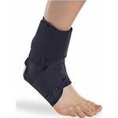**Ankle Brace with Straps**

**HCPCS: L1902**

Indications:

Mild to moderate ankle distortions

Treatment of acute ankle sprain (alternative to taping)

Chronic ankle instability

Prophylactic and therapeutic use in sport activities

Functions:

Lock heel from inversion or eversion by non-elastic cross-stirrup

Strap

Bilateral plastic stays prevent Valgus or Varus deviation

Features:

Made of durable and tough nylon fabric

Extra non-elastic cross-stirrup straps provide maximal stability

Bilateral plastic stays for additional support

Velcro lace closure design for convenient application

Fits right and left foot ankle

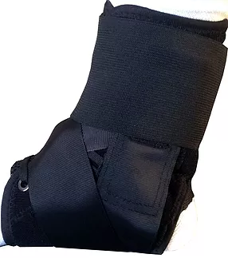**Size: S, M, L**

**Ankle Brace EZ Tie**

**HCPCS: L1902**

Indications:

Mild to moderate sprains and strains

Chronic ankle instabilities

Post-Surgery ankle weakness

​​Benefits:

EZ Pull ties which avoid individual hand lacing

Constructed with non-stretch material for comfort, performance

and durability

Lace-up design and Figure 8 Strapping locks calcaneus into place and controls inversion / Eversion

Elastic cuff provides extra support and compression to help relieve ankle pain

Low profile fits easily into most shoes

**Size: S, M, L**

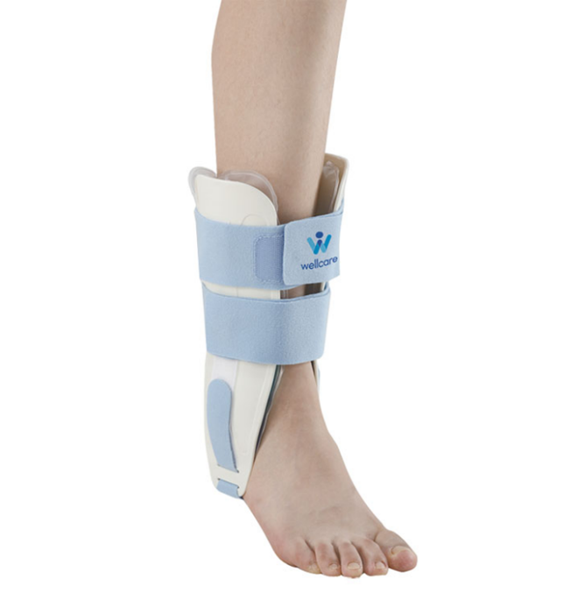**Ankle - AIR/GEL STIRRUP BRACE**

Indications:

Articular effusion and swelling

Moderate ankle sprain with instability

Chronic ankle instability

FEATURES

Anatomically contoured shells support subtalar joint

Bladder combines air and gel for securely stabilizing the ankle joint

Gel can be placed in freezer for cold therapy to swollen ankles

**SIZE: Universal**

**HARD ANKLE BRACE**

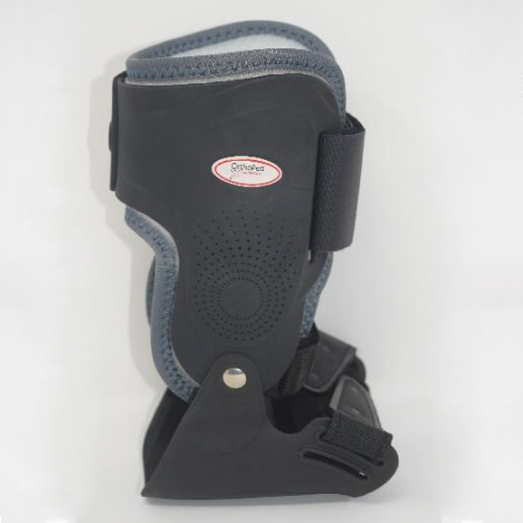**HCPCS: L1971**

**Indications:**

Protection of the ankle joint Varus/valgus

Prevention and rehabilitation of injuries during

outdoor sports.

Damaged tendon, ligament, soft tissue

Of the ankle joint and after surgery

**(Similar to a prefab Richie Brace)**

**Sizes: S-M/ Lg- XL**

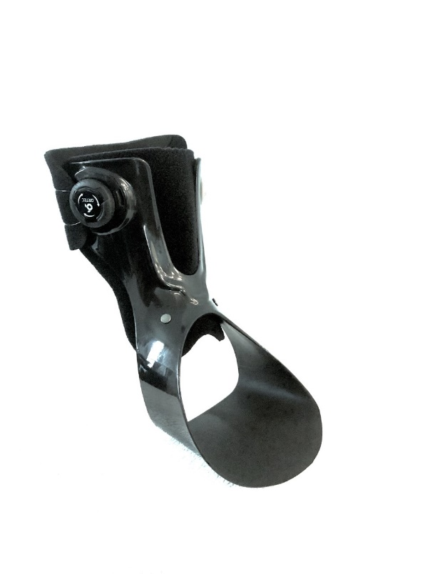

**Flex Step Ankle Brace**

**HCPCS: L1930**

Indication:

Dial lock type

Foot drop due to hemiplegia or peroneal

Nerve palsy

Protection of the ankle joint, Varus/valgus

Prevention and rehabilitation of injuries during

outdoor sports.

Damaged tendon, ligament, soft tissue

of the ankle joint and after surgery.

**Sizes: S, M, L, XL (LT/RT)**

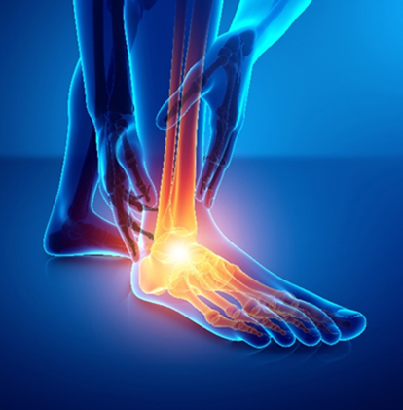

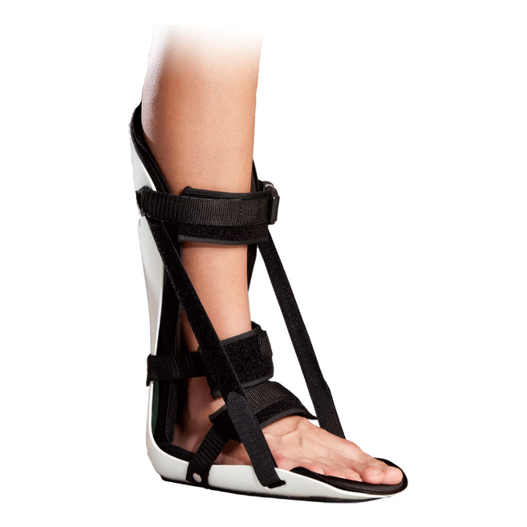**Plantar Fasciitis Stretch Splint**

**HCPCS: L4398**

Indications:

Prevention of drop foot in bed-ridden patient

Plantar fasciitis

Achilles’ tendon repair

Functions:

Immobilization of the foot

Gentle stretch for Achilles tendon and plantar fascia

Features:

Soft velour-lined foam padding for optimal comfort

Prefabricated splint

Adjustable dorsiflexion straps

Minimal house-hold ambulation is possible via pawl surface

under the sole of orthosis

Fits right and left ankle

**Size: S, M, L**

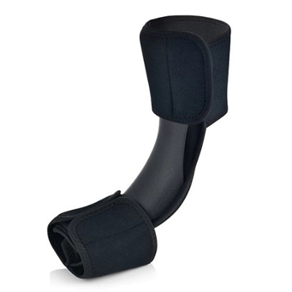**Dorsal Night Splint**

**HCPCs - L4398**

Indications:

Plantar Fasciitis

Achilles Tendinitis

Heel Pain

Calf muscle cramps

Features:

Comfortably stretches the calf and soft tissues of the foot

Adjustable Calf band for custom fit

Helps reduce pain and inflammation

Ultra-soft, lightweight and breathable soft padding for comfort

Adjustable forefoot with open toe

**Size: S, M, L**

**Post OP Shoes**

**Round Toe Mesh Top Post-OP Shoe**

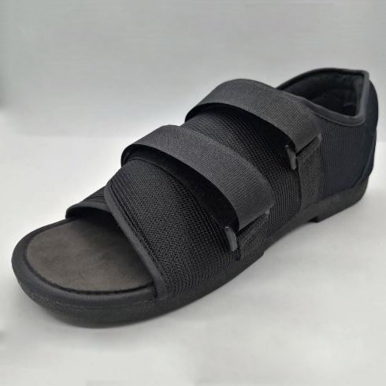Indications:

Following operations or injuries in the forefoot

area

Functions & Features

Low proﬁle – no height compensation necessary

Nylon mesh upper for air circulation

Adjustable hook and loop Velcro straps

**SIZES: Men: S, M, L, XL / Women: S, M, L**

**Square Toe Post-OP Shoe**

Indications:

Following operations or injuries in the forefoot area

Functions & Features

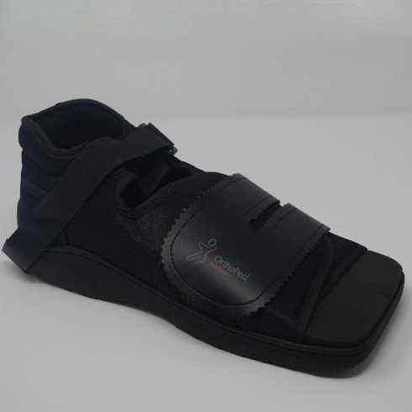Strapless closure on the forefoot

The square toe design acts as a bumper and

provides

additional room

SIZES: Men: S, M, L, XL /Women: S, M, L

**ORTHOPEDIC INSOLES**

Reinforced arch support

Shock absorption design

Deep heel cradle,

Antimicrobial breathable fabric.

Removable layer inside a shoe, that provides extra comfort and support.

When you walk run or stand.

1 (US/M 3-3.5, W 5-5.5):235mm

2 (US/M 4-4.5, W 6-6.5):240mm

3 (US/M 5-5.5, W 7-7.5):247mm

4 (US/M 6-6.5, W 8-8.5):253mm

5 (US/M 7-7.5, W 9-9.5):260mm

6 (US/M 8-8.5, W 10-10.5):267mm

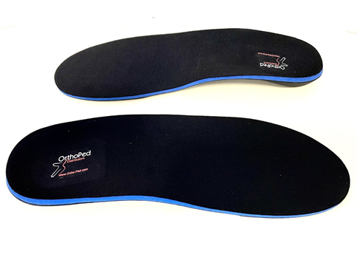7 (US/M 9-9.5, W 11-11.5):273mm

8 (US/M 10-10.5, W 12-12.5):282mm

9 (US/M 11-11.5, W 13-13.5):290mm

10 (US/M 12-12.5, W 14-14.5):298mm

11 (US/M 13-13.5):307cm

12 (US/M 14-14.5):317mm

13 (US/M 15-15.5):327mm

14 (US/M 16-16.5):335mm

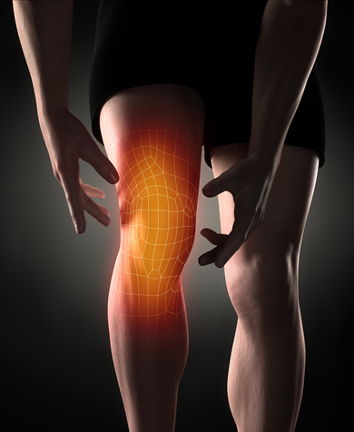**KNEE SUPPORT**

**Uni Fit Hinged Knee Support**

**HCPCS: L1820**

Indications:

Mild to moderate instabilities of knee joint

Mild to moderate strain of the collateral ligaments

Meniscus injuries

Chronic inflammation after operation or trauma

Functions

Collateral stabilization of knee joint prevents

valgus or varus deviation

Prevent hyperextension

Closed cell neoprene with compressive and proprioceptive effect

Increase blood circulation through warm effect

Features

Hinges hidden in pockets offer superior stability.

Wrap around design provides an easy on and off with a custom fit.

Upper and lower fasteners offer further fit.

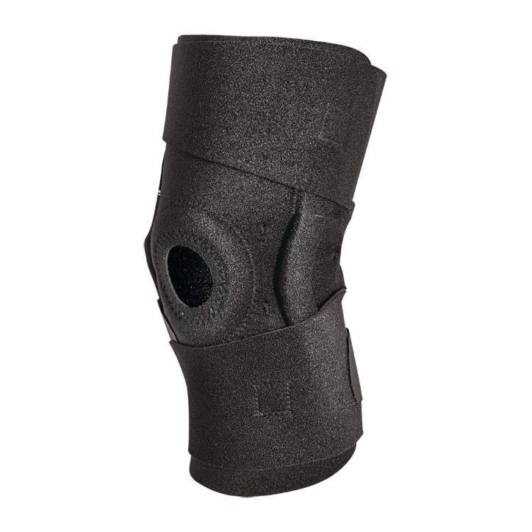

**Size: Universal**

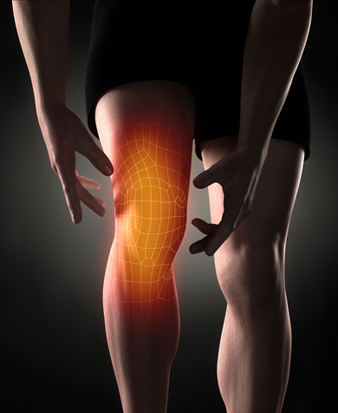**Wrap Around Hinged Knee Support**

**HCPCS: L1832/1833**

Indications:

Meniscus injuries

Mild to moderate instability of knee join

Mild to moderate sprain of the collateral ligaments

Chronic inflammation after operation or trauma

Functions:

Collateral stabilization of knee joint prevents Valgus or

Varus deviation

Prevent hyperextension

Closed cell neoprene with compressive and

proprioceptive effect

Increase blood circulation through warm effect

Features:

3/16” thick neoprene with nylon lining

Open patellar design

Hinges hidden in pockets offer superior stability

Wrap-around version for simple fit

Hook and loop closures above and below knee for secure fit

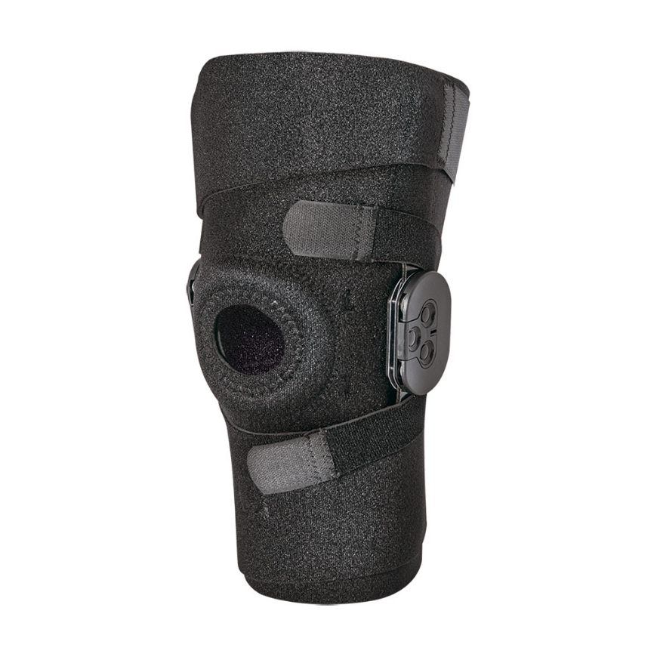Knee Size Guide-Measure around Knee joint

**Size: Universal**

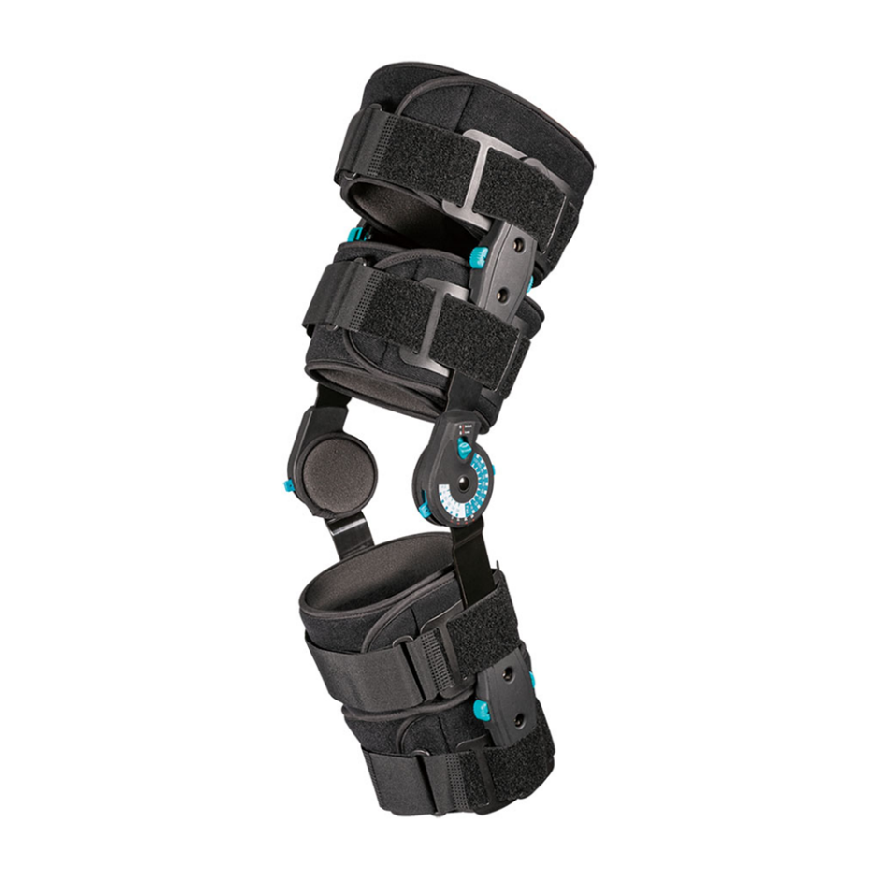**Post OP Knee Brace**

**HCPCS: L1832/L1833**

Indications:

Post-operative immobilization or ROM control

Injured or operated collateral and/or cruciate ligaments

Functions:

Excellent collateral stabilization via long sidebars

prevents Valgus or Varus deviation

Adjustable ROM by simple setting hinges

Features:

Transcendent overall adjustability

Simply press and rotate settings

“One push bottom” can be released for length adjustment

Extension limitation at: 0°, 15°, 30°, 45°, 60°, 75°, 90°

Flexion limitation at: 0°, 15°, 30°, 45°, 60°, 75°, 90°, 105°, 120°

Immobilization limitation at:0°, 15°, 30°, 45°, 60°, 75°, 90°

Length adjustments from 19” to 27”

Cool version can be worn over pants or against the skin

**Size: Universal**

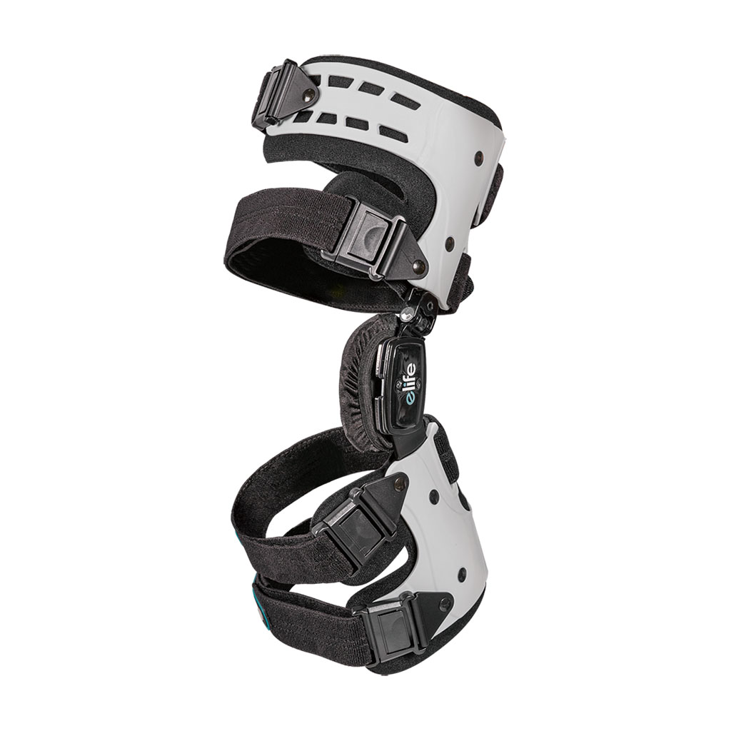

**Unlimit S1 OA Knee Brace**

**HCPCS: L1851**

Indications:

For uni-compartment OA patient

mild to moderate OA knee user

Functions:

Help to support the knee joint and share the loading of affected

joint

Features:

Light weight and superior fit

One size fits most users and allows ergonomically fitting

Ideal for unilateral compartment OA knee users

Valgus and Varus adjustment to fit individual’s alignment

**Size: One size fit most （Left/Right）**



**BACK SUPPORT**

**Roller Speed Spinal System (LSO Panel)**

**HCPCS: L0631/L0648**

**HCPS: L0627**

Indications:

Disc herniation for lumbar spine

Strain or sprain over low back

Spondylolisthesis

Lumbago

Functions:

Wrap around design with back and abdominal panel

Adjustable string roller system perfectly supports the

core muscles

Keep abdominal pressure stable for better tissue healing

After injuries around low back.

**Size: Universal**

**High Profile Back**

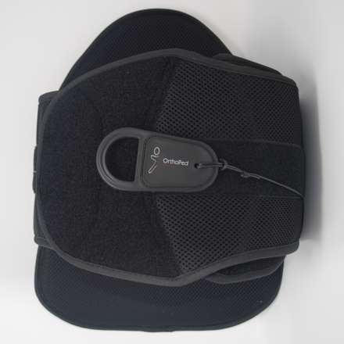

**Low Profile Back**

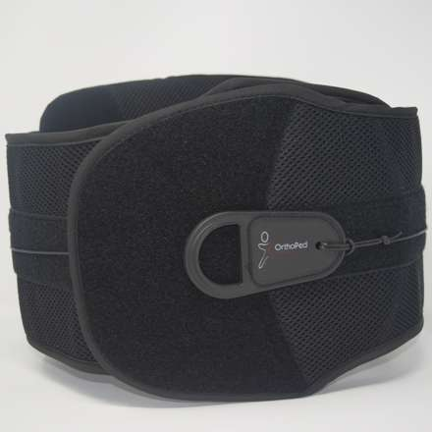



**HAND, ELBOW &**

**SHOULDER**

**SUPPORT**

**Wrist Splint**

**HCPCS: L3908**

Indications:

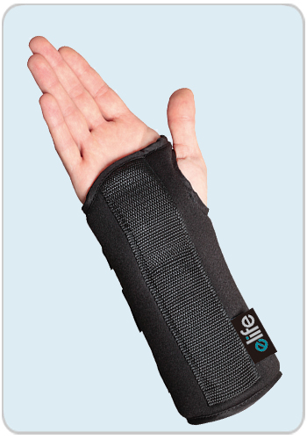Carpal Tunnel Syndrome

Wrist instability due to triangular fibrocartilage

complex (TFCC)injury

Radial nerve paralysis

Rheumatoid arthritis

Functions:

Immobilization of the wrist

Features:

Breathable open cell foam material

Anatomically contoured aluminum palmar splint

V-notch at fifth MP for palmar spread

**Size: XS, S, M, L**

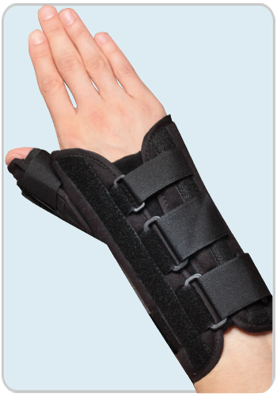**Thumb Wrist and Palm Splint**

**HCPCS: L3807**

Indications:

Carpal Tunnel Syndrome

First metacarpophalangeal or carpometacarpal joint injury

De Quervain’s tenosynovitis & Gamekeeper’s thumb

Ligamentous laxity of the thumb （skier’s thumb）

Radial nerve paralysis

Rheumatoid arthritis or degenerative arthritis at the thumb

Functions:

Immobilization of the wrist and thumb

Features:

Breathable open cell foam material

Anatomically contoured aluminum palmar splint

Rigid thumb stays for custom fit

V-notch at fifth MP for palmar spread

**Size: XS, S, M, L**

**Shoulder Abduction Sling**

**HCPCS: L3670**

Shoulder abduction sling, including abduction pillow to help avoid adhesions to axillary recess.

Includes abduction pillow

Foam padded strap and shoulder pad for optimal comfort

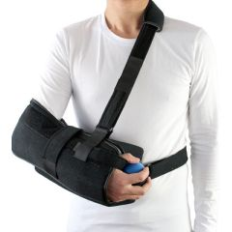Includes thumb loop

Comfortable hand rest, Exercise ball stimulates circulation

Fits left or right shoulder

Ball for exercise

Indications for Use:

Immobilization following rotator cuff repair, TSR

Capsule release/repair, Humeral head dislocation

**Universal design fits right or left arm**

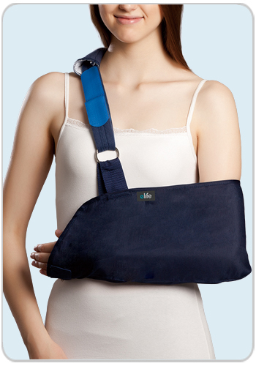**Shoulder Immobilizer**

**HCPCS: L3660**

Indications:

Standard Shoulder Immobilizer

Indications for use:

Soft tissue repairs and strains

Shoulder and arm instabilities and injuries

​Features:

Comfortable cotton envelope

Adjustable shoulder strap that limits wrist drop and

prevents migration

**Universal design fits right or left arm**

(ALL BLACK)

**POST-OP Elbow Brace**

**HCPCS: L3760**

Indications:

Post-operative immobilization or ROM control for the elbow

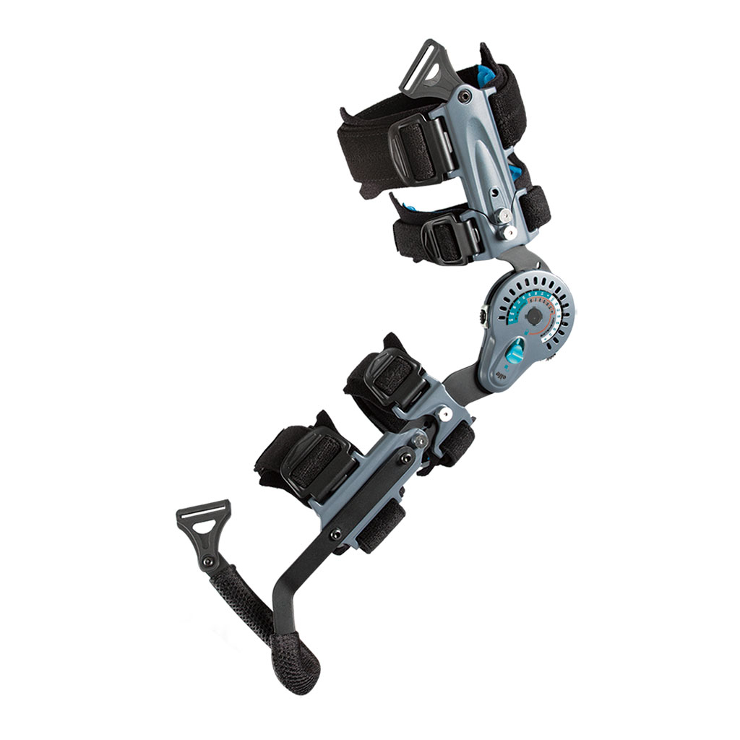Conservative treatment of elbow dislocation or luxation

Stable or internally fixed fractures of the distal

humerus or proximal radius or ulna

Functions:

Immobilization of the elbow in 10~15° increments

Limit ROM by adjustable simple setting hinges

Features:

Padded lined malleable aluminum cuffs for a

perfect fit

Light weight but streamlined durable aluminum

hinge provides maximum protection

“Pull pin design” enables easy release for

Slide-to-Size length adjustments.

Simply press and rotate hinge with lock

Extension limitation from 0° ~ 105°

Flexion limitation from 0° ~ 120°

Lock limitation from 0° ~ 90°

Adjustable in every 15 degrees

**Sizing: Universal Left/ Right**

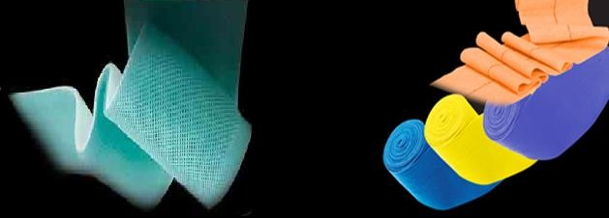

OrthoPed Distributors

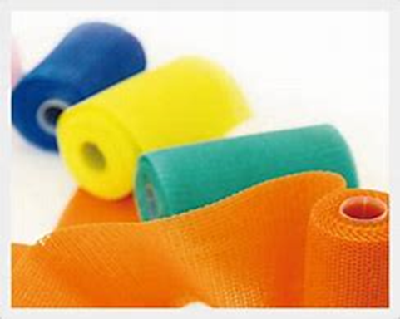

**Colors:**

White Black

Pink Purple

Red Blue

Camo green, pink, blue

**New Colors:**

NEON Pink

NEON Green

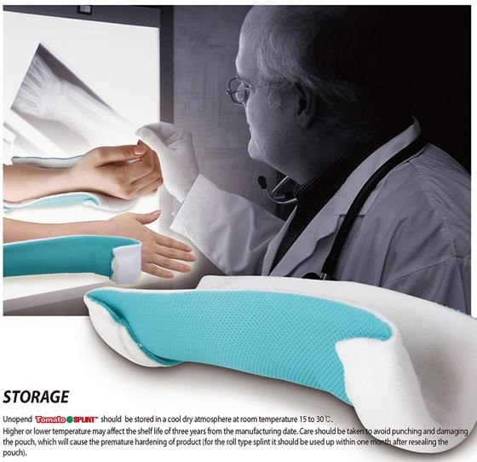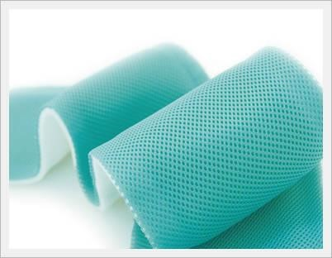

**SPLINT - Splint Roll**





**CAST PADDING: 2”, 3” and 4” (100% Cotton)**

Extreme softness with volume makes superior comfortability

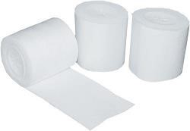Once binding up, won’t be come off easily

100% Cotton minimizes skin troubles

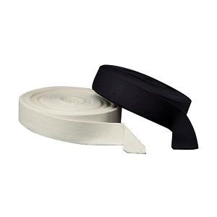

**Stockinette: 2” and 3” (Black and Beige)**

Soft & moderate elasticity offers more comfortability to patient

100% Cotton minimizes skin troubles

**Water Repellent Cast Pad: 2”, 3” and 4”**

POLYESTER 100%

4 Layer material with flexible and unique structure that can help in the function of water drain, ventilation and cushioning. Glue coated to avoid slippage.

Patient can take shower and/or play with water.

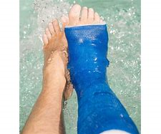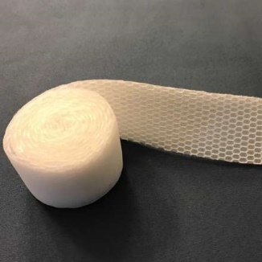



|  |  |
| --- | --- |
| **PRODUCT CODE** | **DESCRIPTION** |
| TRS-002 | Splint 2” X 5 yards |
| TRS-003 | Splint 3” X 5 yards |
| TRS-004 | Splint 4” X 5 yards |
| TRS-005 | Splint 5” X 5 yards |
| TCR-002 | Solid Tomato Cast 2” Box of 10 |
| TCR-003 | Solid Tomato Cast 3” Box of 10 |
| TCR-004 | Solid Tomato Cast 4” Box of 10 |
| TCR-002 (Patterned) | Tomato Cast 2” Box of 10 |
| TCR-003 (Patterned) | Tomato Cast 3” Box of 10 |
| TCR-004 (Patterned) | Tomato Cast 4” Box of 10 |
| St-02 Black | Stockinet 2 x 25yds Black |
| St-03 Black | Stockinet 3 x 25yds Black |
| St-02 Beige | Stockinet 2 x 25yds Beige |
| St-03 Beige | Stockinet 2 x 25yds Beige |
| Cst-padding 2 | Cast padding 100 % cotton 2” |
| Cst- Padding 3 | Cast padding 100% cotton 3” |
| Cst- Padding 4 | Cast padding 100% cotton 4” |
| Water Repellent Cast Padding 2" | 2” Water Repellent Cast Pad |
| Water Repellent Cast Padding 3" | 3” Water Repellent Cast Pad |
| Water Repellent Cast Padding 4" | 4” Water Repellent Cast Pad |
|  |  |

**OrthoPed Distributors Corp.**

* FDA Registered Products- 3010479400
* All products are registered with PDAC



Visit our website:

[WWW.ORTHOP-PED.COM](http://WWW.ORTHOP-PED.COM)

**Wintergarden, Florida Office:**

1261 Wintergarden Vineland Rd. 120,

Wintergarden Fl. 34787

Tel. 407-353-4144, Fax: 407-395-2803, Cell. 787-317-4702

rcollazo@ortho-ped.com

Contact Person:

Jose Garcia/ Rochelle Collazo